STEPS TO CREATE A NEW USER AND ASSIGN ROLES

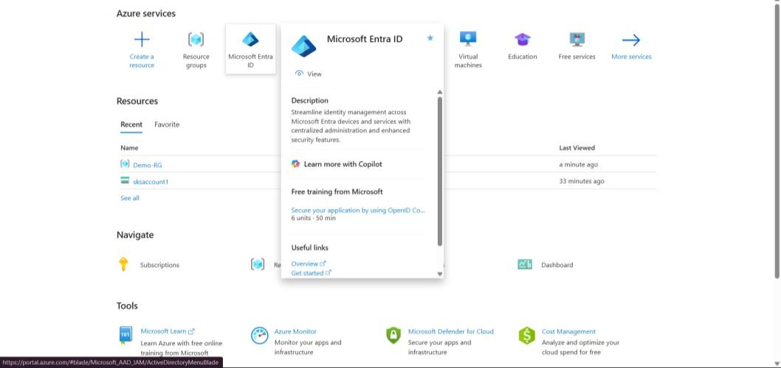
Use MicrosoftEntraID to create a new user.
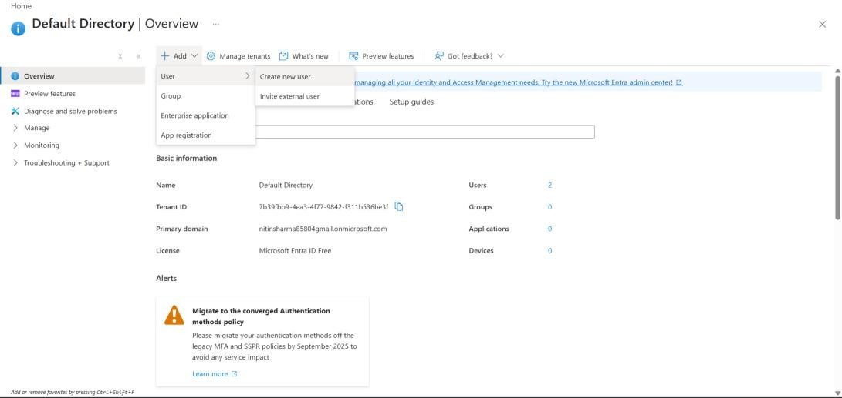
Create a new User using this tab.
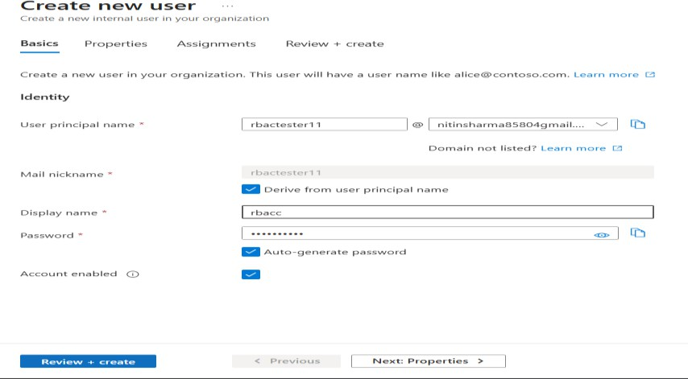
22BCS14971@cuchd.in

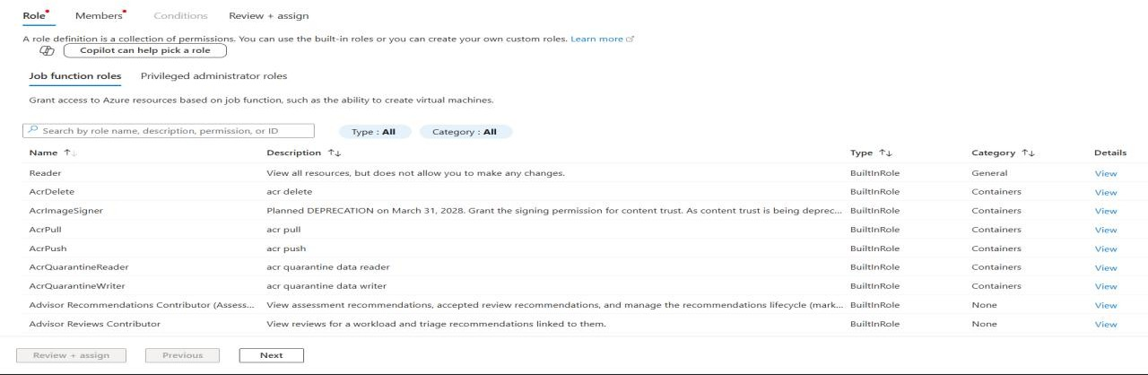
Create new User and give principle name and password and copy both of them.
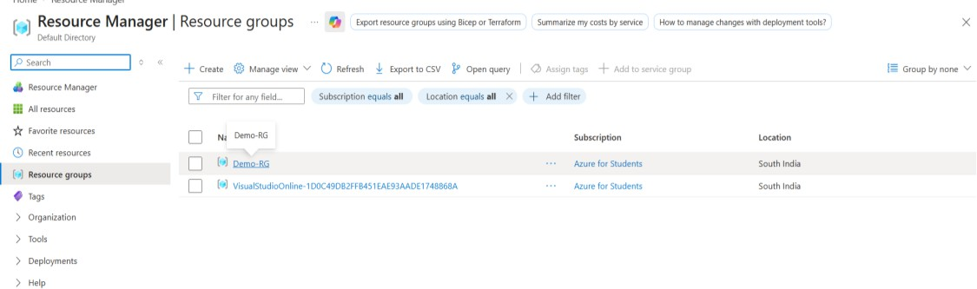
Now go to your created Resource Group
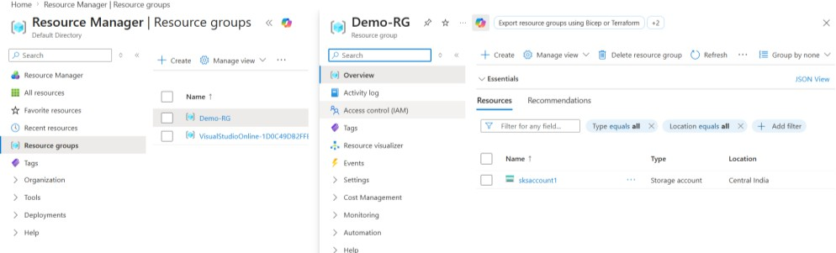
Identity Access Management in access control and then create role
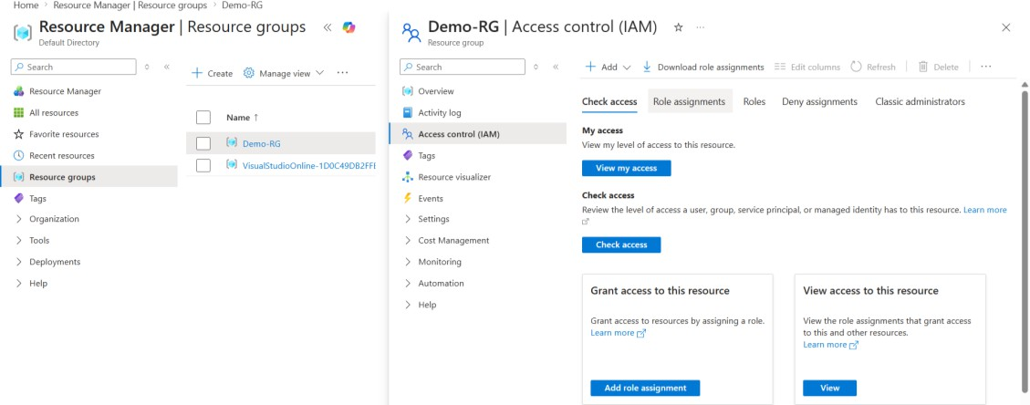
Assign roles

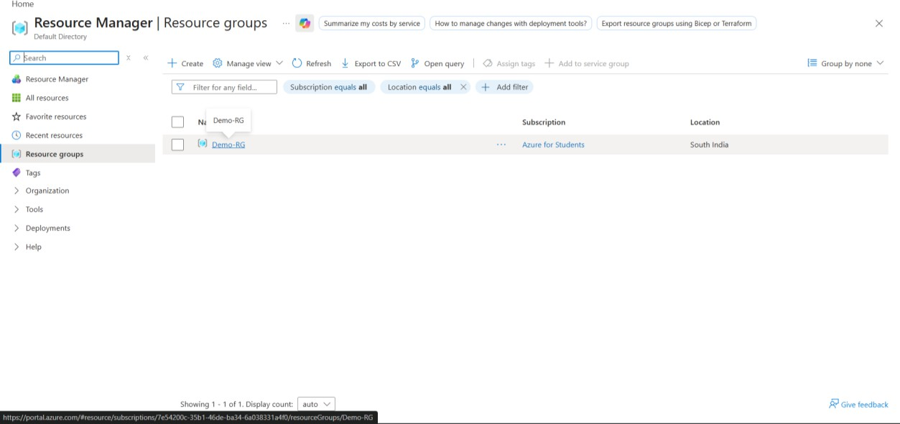
Assing reader as per doccument.
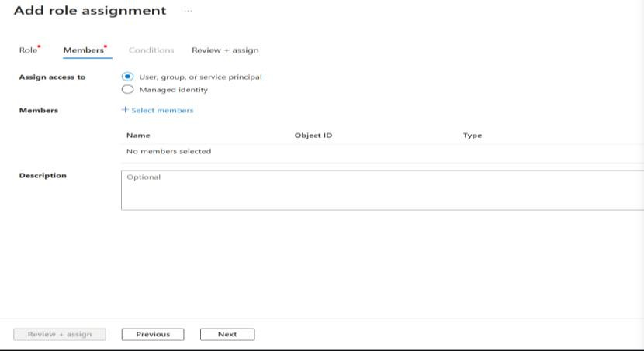
Then Review and assign.

On new incognito tab you can see the resource group with the new user account as it is assigned reader.

